LAB: Search QL Account

Thông tin chung
- Xây dựng chức năng Search trên Backend
- Sử dụng kỹ thuật Specification được Spring hỗ trợ.
- Tích hợp các chức năng Search theo các trường: Email, FullName và Department, xuất dữ liệu API cho Frontend.
- Các bước thực hiện:
- Bước 1: Thực hiện Extend: JpaSpecificationExecutor (import org.springframework.data.jpa.repository.JpaSpecificationExecutor;) tại IAccountRepository cần thực hiện Search, ở đây đang cần search cho bảng Account.
- Bước 2: Tạo thêm Packet: com.vti.specification, và Class AccountSpecification trong package này, Class cần implements Specification<Account>, class này sẽ định nghĩa ra các điều kiện tìm kiếm, chú ý định nghĩa ra các thuộc tính: field, operator, value.
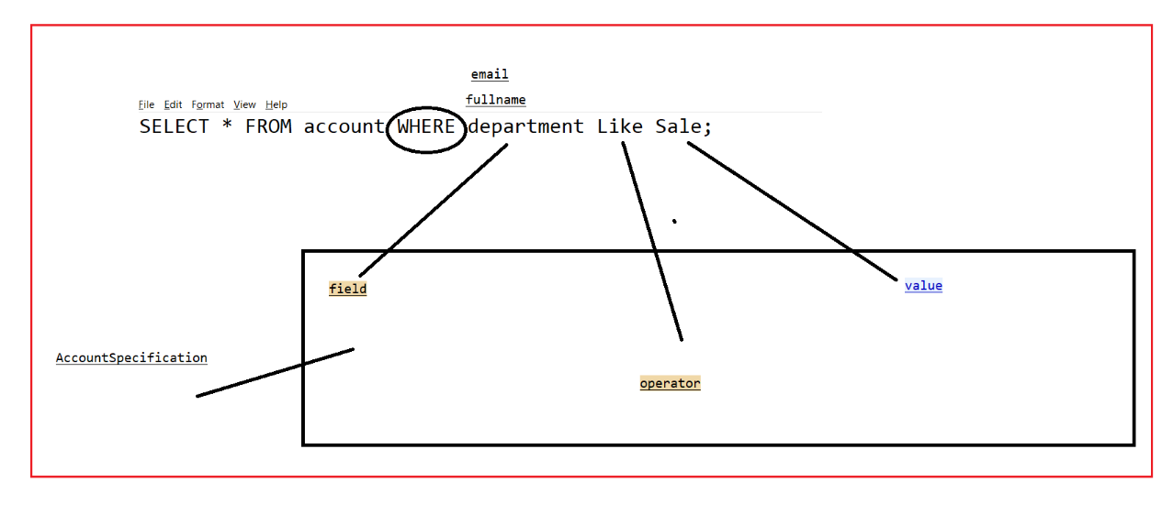
package com.vti.specification;

import javax.persistence.criteria.CriteriaBuilder;
import javax.persistence.criteria.CriteriaQuery;
import javax.persistence.criteria.Predicate;
import javax.persistence.criteria.Root;

import org.springframework.data.jpa.domain.Specification;

import com.vti.entity.Account;

public class AccountSpecification implements Specification<Account> {
private String field;
private String operator;
private Object value;

public AccountSpecification(String field, String operator, Object value) {
this.field = field;
this.operator = operator;
this.value = value;
}

@Override
public Predicate toPredicate(Root<Account> root, CriteriaQuery<?> query, CriteriaBuilder builder) {
if (operator.equalsIgnoreCase("LIKE")) {

if (field.equalsIgnoreCase("department.name")) {
return builder.like(root.get("department").get("name"), "%" + value.toString() + "%");
} else {
return builder.like(root.get(field), "%" + value.toString() + "%");
}
}
return null;
}

}

- Bước 3: Thêm @RequestParam(required = false) String search vào Controller tương ứng để lấy dữ liệu Search từ Frontend đẩy về, đồng thời sửa lại hàm accountService.getAllAccount(pageable, search); cho tương ứng.
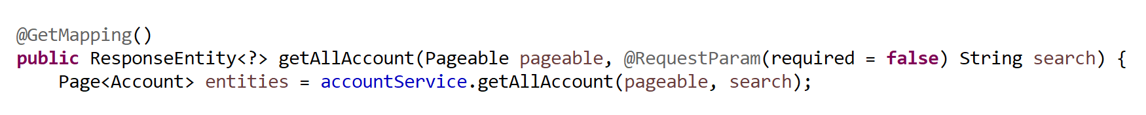
- Bước 4: Thực hiện sửa lại hàm getAllAccount trong IAccountService cho phù hợp với Controller.
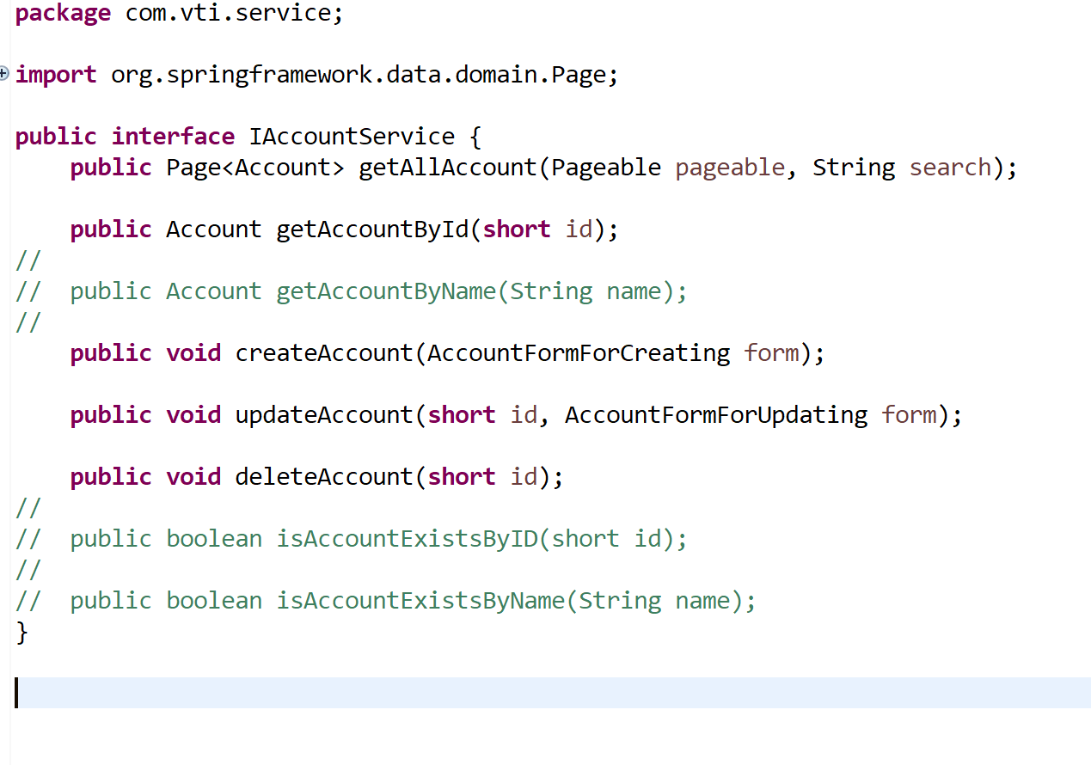
public Page<Account> getAllAccount(Pageable pageable, String search);

- Bước 5: Sửa lại class AccountService sau khi đã thay đổi IAccountService
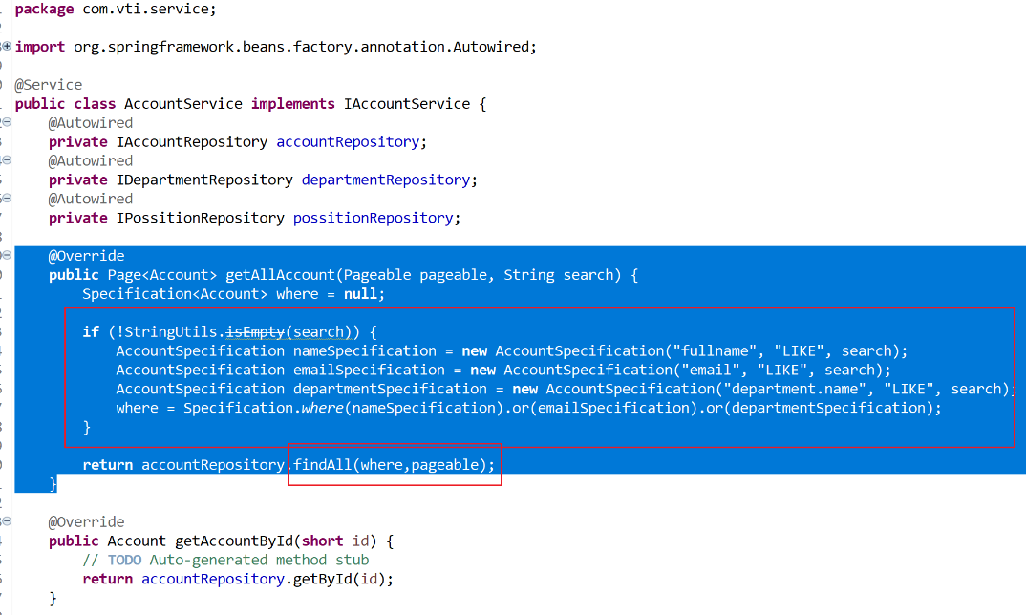
@Override
public Page<Account> getAllAccount(Pageable pageable, String search) {
Specification<Account> where = null;

if (!StringUtils.isEmpty(search)) {
AccountSpecification nameSpecification = new AccountSpecification("fullname", "LIKE", search);
AccountSpecification emailSpecification = new AccountSpecification("email", "LIKE", search);
AccountSpecification departmentSpecification = new AccountSpecification("department.name", "LIKE", search);
where = Specification.where(nameSpecification).or(emailSpecification).or(departmentSpecification);
}

return accountRepository.findAll(where,pageable);
}

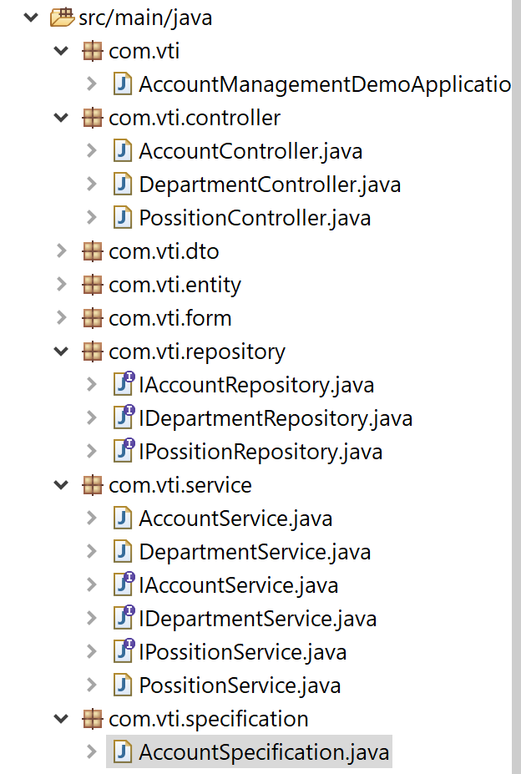

- Chú ý Extend thêm JpaSpecificationExecutor ở interface IaccountRepository,Class này sẽ hỗ trợ Specification

Sửa Class AccountController
- Thực hiện nhận lại dữ liệu cần tìm kiếm thông qua tham số Search từ Frontend đẩy về.

package com.vti.controller;

import java.util.function.Function;

import org.springframework.beans.factory.annotation.Autowired;
import org.springframework.data.domain.Page;
import org.springframework.data.domain.Pageable;
import org.springframework.http.HttpStatus;
import org.springframework.http.ResponseEntity;
import org.springframework.web.bind.annotation.DeleteMapping;
import org.springframework.web.bind.annotation.GetMapping;
import org.springframework.web.bind.annotation.PathVariable;
import org.springframework.web.bind.annotation.PostMapping;
import org.springframework.web.bind.annotation.PutMapping;
import org.springframework.web.bind.annotation.RequestBody;
import org.springframework.web.bind.annotation.RequestMapping;
import org.springframework.web.bind.annotation.RequestParam;
import org.springframework.web.bind.annotation.RestController;

import com.vti.dto.AccontDto;
import com.vti.entity.Account;
import com.vti.form.AccountFormForCreating;
import com.vti.form.AccountFormForUpdating;
import com.vti.service.IAccountService;

@RestController
@RequestMapping(value = "api/v1/accounts")
public class AccountController {

@Autowired
private IAccountService accountService;

@GetMapping()
public ResponseEntity<?> getAllAccount(Pageable pageable, @RequestParam(required = false) String search) {
Page<Account> entities = accountService.getAllAccount(pageable, search);

// convert entities --> dtos
// https://stackoverflow.com/questions/39036771/how-to-map-pageobjectentity-to-pageobjectdto-in-spring-data-rest
Page<AccontDto> dtoPage = entities.map(new Function<Account, AccontDto>() {
@Override
public AccontDto apply(Account account) {
AccontDto dto = new AccontDto(account.getId(), account.getEmail(), account.getUsername(),
account.getFullname(), account.getDepartment().getName(),
account.getPosition().getName().toString(), account.getCreateDate());
return dto;
}
});

return new ResponseEntity<>(dtoPage, HttpStatus.OK);
}

@GetMapping(value = "/{id}")
public ResponseEntity<?> getAccountByID(@PathVariable(name = "id") short id) {
Account account = accountService.getAccountById(id);
AccontDto dto = new AccontDto(account.getId(), account.getEmail(), account.getUsername(), account.getFullname(),
account.getDepartment().getName(), account.getPosition().getName().toString(), account.getCreateDate());
return new ResponseEntity<AccontDto>(dto, HttpStatus.OK);
}

@PostMapping()
public ResponseEntity<?> createDepartment(@RequestBody AccountFormForCreating form) {
accountService.createAccount(form);
return new ResponseEntity<String>("Create successfully!", HttpStatus.CREATED);
}

@PutMapping(value = "/{id}")
public ResponseEntity<?> updateDepartment(@PathVariable(name = "id") short id,
@RequestBody AccountFormForUpdating form) {
accountService.updateAccount(id, form);
return new ResponseEntity<String>("Update successfully!", HttpStatus.OK);
}

@DeleteMapping(value = "/{id}")
public ResponseEntity<?> deleteAccount(@PathVariable(name = "id") short id) {
accountService.deleteAccount(id);
return new ResponseEntity<String>("Delete successfully!", HttpStatus.OK);
}

}

Sửa Interface IAccountService
- Trong hàm getAllAccount() cần phải truyền vào tham số search để tìm kiếm.
package com.vti.service;

import org.springframework.data.domain.Page;
import org.springframework.data.domain.Pageable;

import com.vti.entity.Account;
import com.vti.form.AccountFormForCreating;
import com.vti.form.AccountFormForUpdating;

public interface IAccountService {
public Page<Account> getAllAccount(Pageable pageable, String search);

public Account getAccountById(short id);
//
// public Account getAccountByName(String name);
//
public void createAccount(AccountFormForCreating form);

public void updateAccount(short id, AccountFormForUpdating form);

public void deleteAccount(short id);
//
// public boolean isAccountExistsByID(short id);
//
// public boolean isAccountExistsByName(String name);
}

Sửa Class AccountService

package com.vti.service;

import org.springframework.beans.factory.annotation.Autowired;
import org.springframework.data.domain.Page;
import org.springframework.data.domain.Pageable;
import org.springframework.data.jpa.domain.Specification;
import org.springframework.stereotype.Service;
import org.springframework.util.StringUtils;

import com.vti.entity.Account;
import com.vti.entity.Department;
import com.vti.entity.Position;
import com.vti.form.AccountFormForCreating;
import com.vti.form.AccountFormForUpdating;
import com.vti.repository.IAccountRepository;
import com.vti.repository.IDepartmentRepository;
import com.vti.repository.IPossitionRepository;
import com.vti.specification.AccountSpecification;

@Service
public class AccountService implements IAccountService {
@Autowired
private IAccountRepository accountRepository;
@Autowired
private IDepartmentRepository departmentRepository;
@Autowired
private IPossitionRepository possitionRepository;

@SuppressWarnings("deprecation")
@Override
public Page<Account> getAllAccount(Pageable pageable, String search) {

Specification<Account> where = null;

if (!StringUtils.isEmpty(search)) {
AccountSpecification nameSpecification = new AccountSpecification("fullname", "LIKE", search);
AccountSpecification emailSpecification = new AccountSpecification("email", "LIKE", search);
AccountSpecification departmentSpecification = new AccountSpecification("department.name", "LIKE", search);
where = Specification.where(nameSpecification).or(emailSpecification).or(departmentSpecification);
}

return accountRepository.findAll(where, pageable);

}

@Override
public Account getAccountById(short id) {
// TODO Auto-generated method stub
return accountRepository.getById(id);
}

@Override
public void deleteAccount(short id) {
accountRepository.deleteById(id);

}

@Override
public void createAccount(AccountFormForCreating form) {
Account account = new Account();
Department department = departmentRepository.getById(form.getDepartmentId());
Position position = possitionRepository.getById(form.getPositionId());
account.setEmail(form.getEmail());
account.setUsername(form.getUsername());
account.setFullname(form.getFullname());
account.setDepartment(department);
account.setPosition(position);
accountRepository.save(account);
}

@Override
public void updateAccount(short id, AccountFormForUpdating form) {
Account account = accountRepository.getById(id);
Department department = departmentRepository.getById(form.getDepartmentId());
Position position = possitionRepository.getById(form.getPositionId());
account.setFullname(form.getFullname());
account.setDepartment(department);
account.setPosition(position);
accountRepository.save(account);
}

}

Sửa Interface IAccountRepository
- Thực hiện Extend JpaSpecificationExecutor để hỗ trợ tìm kiếm.

package com.vti.repository;

import org.springframework.data.jpa.repository.JpaRepository;
import org.springframework.data.jpa.repository.JpaSpecificationExecutor;

import com.vti.entity.Account;

public interface IAccountRepository extends JpaRepository<Account, Short>, JpaSpecificationExecutor<Account> {

}

Tạo Class AccountSpecification
- Trong Class này khai báo để tạo ra các điều kiện Where trong tìm kiếm, cần implement từ Specification
private String field; định nghĩa ra trường cần tìm kiếm: email, fulllname
private String operator; định nghĩa ra toán tử tìm kiếm: Like
private Object value; định nghĩa ra giá trị cần tìm kiếm: do các giá trị này không có kiểu dữ liệu cố định nên để là Object, lúc cần sử dụng sẽ ép kiểu để có giá trị mong muốn.

package com.vti.specification;

import javax.persistence.criteria.CriteriaBuilder;
import javax.persistence.criteria.CriteriaQuery;
import javax.persistence.criteria.Predicate;
import javax.persistence.criteria.Root;

import org.springframework.data.jpa.domain.Specification;

import com.vti.entity.Account;

public class AccountSpecification implements Specification<Account> {

private static final long serialVersionUID = 1L;

private String field;
private String operator;
private Object value;
// Hàm khởi tạo
public AccountSpecification(String field, String operator, Object value) {
this.field = field;
this.operator = operator;
this.value = value;
}

@Override
public Predicate toPredicate(Root<Account> root, CriteriaQuery<?> query, CriteriaBuilder builder) {
if (operator.equalsIgnoreCase("LIKE")) {

if (field.equalsIgnoreCase("department.name")) {
return builder.like(root.get("department").get("name"), "%" + value.toString() + "%");
} else {
return builder.like(root.get(field), "%" + value.toString() + "%");
}
}
return null;
}

}

Chạy chương trình Demo kết quả
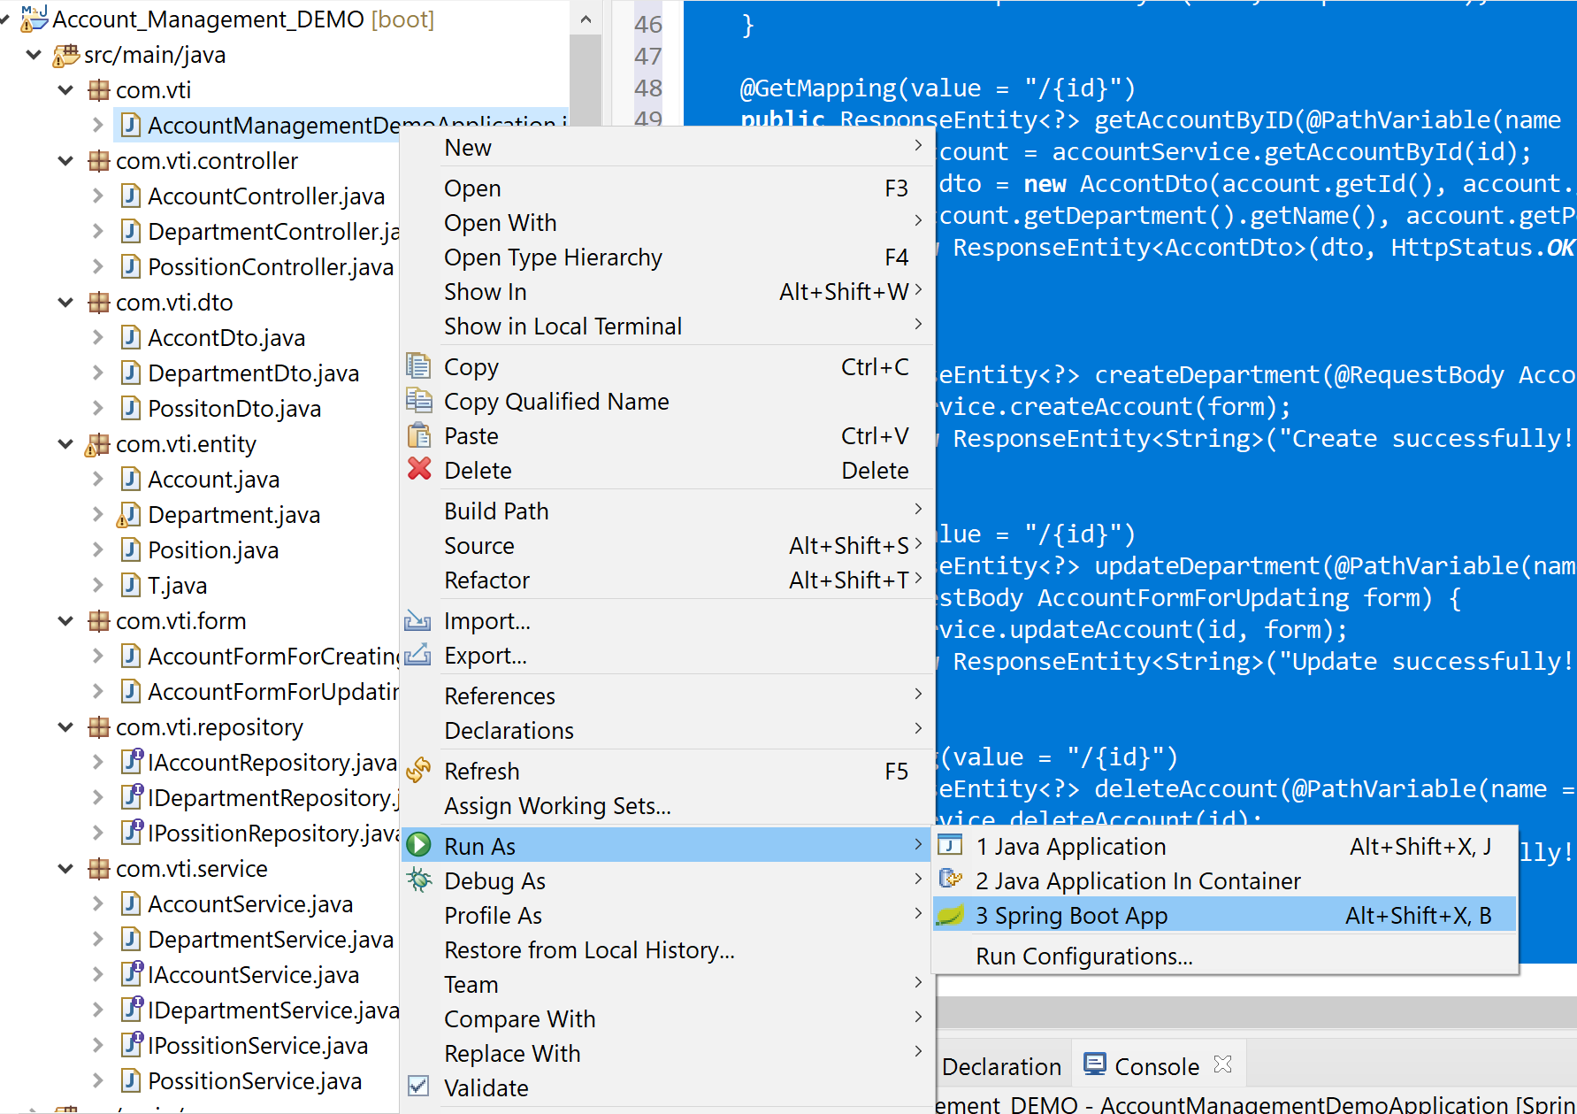

Sử dụng Postman để Demo kết quả API với Account

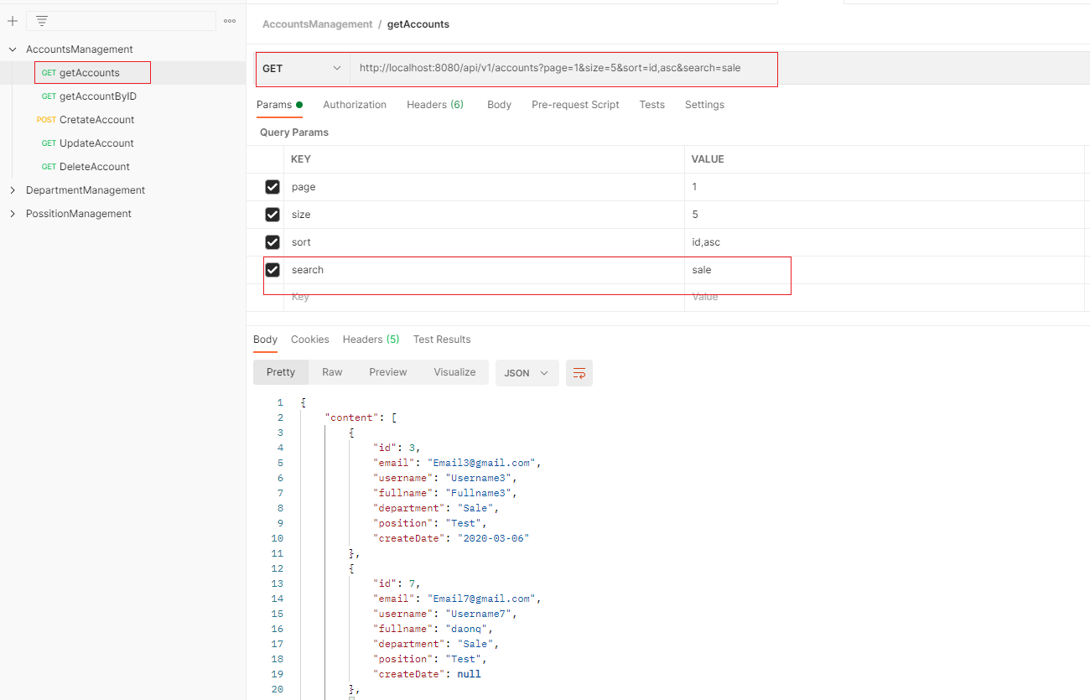
- Thực hiện Add các Request:
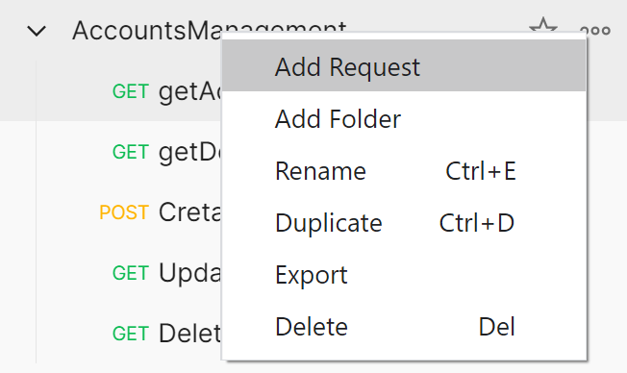

- Get All Account: chú ý điền đúng tên các tham số, có phân biệt chữ hoa, chữ thường. phần demo này có thể search theo Email, Fullname, Department.
http://localhost:8080/api/v1/accounts?page=1&size=5&sort=id,asc&search=sale
sort: id,desc
sort: id,asc
search: sale

Demo tạo API cho chức năng Search bảng Department.
- Tạo Class DepartmentSpecification trong com.vti.specification;
package com.vti.specification;

import javax.persistence.criteria.CriteriaBuilder;
import javax.persistence.criteria.CriteriaQuery;
import javax.persistence.criteria.Predicate;
import javax.persistence.criteria.Root;

import org.springframework.data.jpa.domain.Specification;

import com.vti.entity.Department;

public class DepartmentSpecification implements Specification<Department> {
private String field;
private String operator;
private Object value;

public DepartmentSpecification(String field, String operator, Object value) {
this.field = field;
this.operator = operator;
this.value = value;
}

@Override
public Predicate toPredicate(Root<Department> root, CriteriaQuery<?> query, CriteriaBuilder criteriaBuilder) {
if (operator.equalsIgnoreCase("LIKE")) {

return criteriaBuilder.like(root.get(field), "%" + value.toString() + "%");
}
return null;
}

}

- Sửa Class DepartmentController , sửa lại hàm getAllDepartments thêm trường search
package com.vti.controller;

import java.util.ArrayList;
import java.util.List;

import org.springframework.beans.factory.annotation.Autowired;
import org.springframework.http.HttpStatus;
import org.springframework.http.ResponseEntity;
import org.springframework.web.bind.annotation.CrossOrigin;
import org.springframework.web.bind.annotation.GetMapping;
import org.springframework.web.bind.annotation.RequestMapping;
import org.springframework.web.bind.annotation.RequestParam;
import org.springframework.web.bind.annotation.RestController;

import com.vti.dto.DepartmentDto;
import com.vti.entity.Department;
import com.vti.service.IDepartmentService;

@RestController
@RequestMapping(value = "api/v1/departments")
@CrossOrigin("*")
public class DepartmentController {

@Autowired
private IDepartmentService departmentService;

@GetMapping()
public ResponseEntity<?> getAllDepartments(@RequestParam(required = false) String search ) {
List<Department> entities = departmentService.getAllDepartments(search);

List<DepartmentDto> dtos = new ArrayList<>();

// convert entities --> dtos
for (Department entity : entities) {
DepartmentDto dto = new DepartmentDto(entity.getId(), entity.getName());
dtos.add(dto);
}

return new ResponseEntity<>(dtos, HttpStatus.OK);
}

}

- Sửa Class IDepartmentService, sửa lại hàm getAllDepartments thêm trường search
package com.vti.service;

import java.util.List;

import com.vti.entity.Department;

public interface IDepartmentService {

public List<Department> getAllDepartments(String search);

}

- Sửa Class DepartmentService, sửa lại hàm getAllDepartments thêm trường search
package com.vti.service;

import java.util.List;

import org.springframework.beans.factory.annotation.Autowired;
import org.springframework.data.jpa.domain.Specification;
import org.springframework.stereotype.Service;
import org.springframework.util.StringUtils;

import com.vti.entity.Department;
import com.vti.repository.IDepartmentRepository;
import com.vti.specification.DepartmentSpecification;

@Service
public class DepartmentService implements IDepartmentService {

@Autowired
private IDepartmentRepository departmentRepository;

public List<Department> getAllDepartments(String search) {
Specification<Department> where = null;

if (!StringUtils.isEmpty(search)) {
DepartmentSpecification nameSpecification = new DepartmentSpecification("name", "LIKE", search);
where = Specification.where(nameSpecification);
}

return departmentRepository.findAll(where);
}

}

- Demo lại trên Postman:
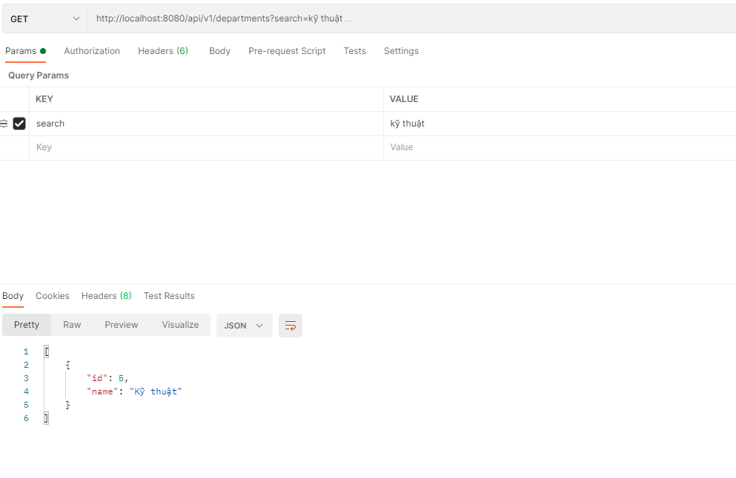
http://localhost:8080/api/v1/departments?search=kỹ thuật

